

Marigold Days
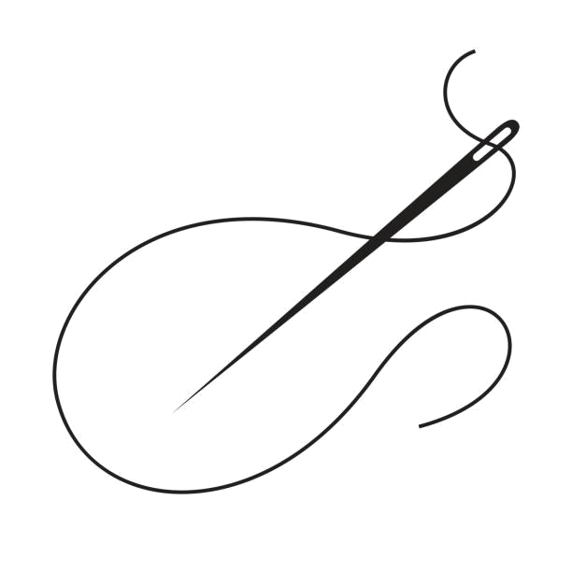
Quilt Show
2025

Quilt Makers
& Collectors
We are seeking quilted treasures for display
during this year’s festival.

All quilts must be brought to the Opera House,
Thursday, September 4 between 4 and 7 p.m.
This gives us time to display your entries.

The quilt show is open on
Saturday, September 6
9am until 5pm
and
Sunday, September 7
9am until 3pm

You will be able to pick up your entered quilts on
Sunday, Sept. 10
at 4pm

Cash award given to winners of Viewers’ Choice
Any questions? Please contact: Barb at bloquai@kmtel.com
www.marigolddays.com

Marigold Days Quilt Show Registration

Name _____________________________________________________

Address ___________________________________________________

Phone number ______________________________________________

Quilt Categories
1-Small- Baby quilt, throw, single, (less than 200" perimeter)
2-Large-double, queen or king, (more than 200 " perimeter)
3-Other quilted item- table runner, wall hanging, wearables

Information regarding your quilt/quilts

Pattern Name ___________________________

Made by ________________________________

Date made ______________________________

History or background of quilt ________________________________________________________________________________________________________________________
________________________________________________________________________________________________________________________________________________________________________________________________________________________________________________________________________________________________________________________________________________________________________

